Name: Mriganka Patra
Email: mriganka.patra@cognizant.com
Emp ID: 2415820

Day 18
Sprint 1 Submission

Objective: Implement the base CRM logic with record types, automation, visibility settings, and user management.

Task 1.7: As a system I want to auto-create an Opportunity when a new Account is added so that sales tracking begins immediately.

- Go to Setup

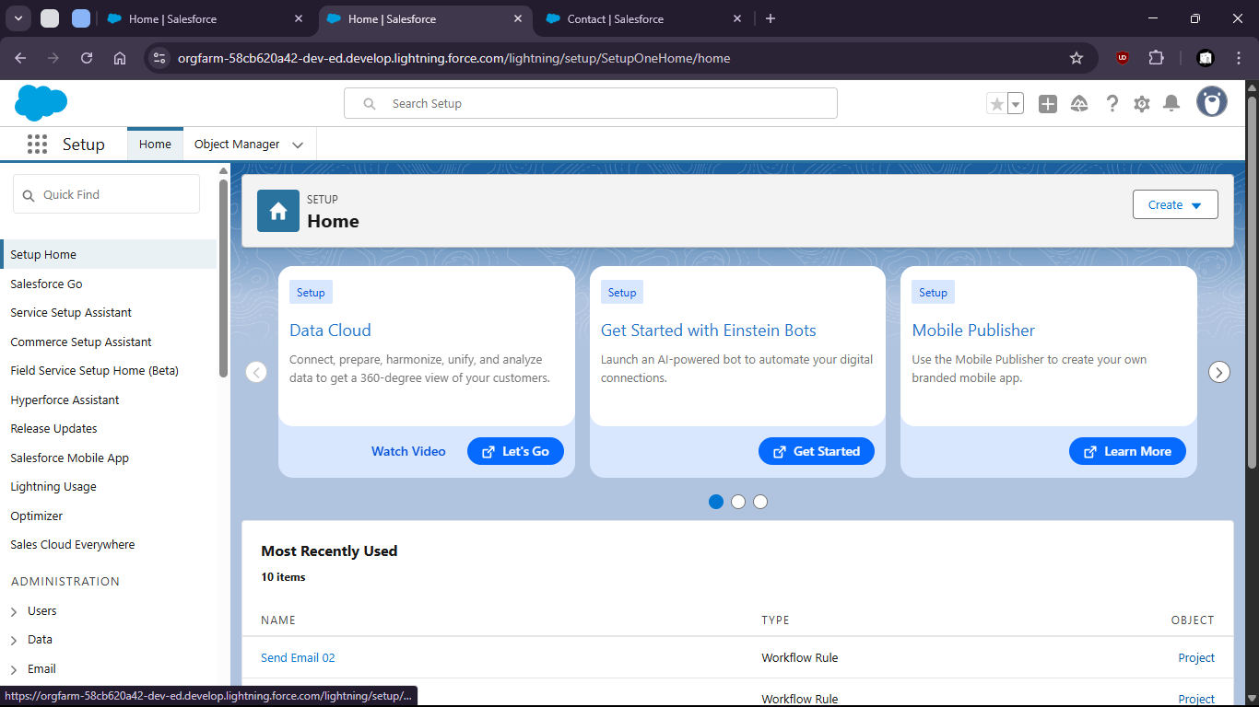

- Search for “Flows”

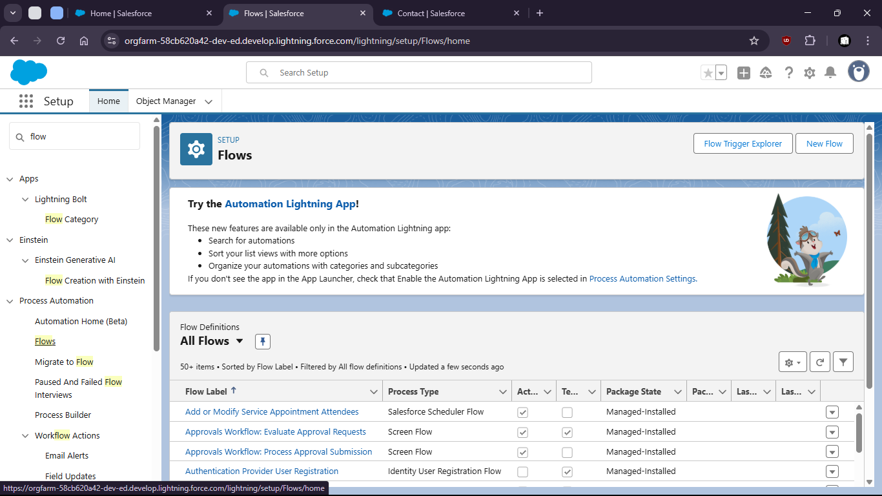

- Click new

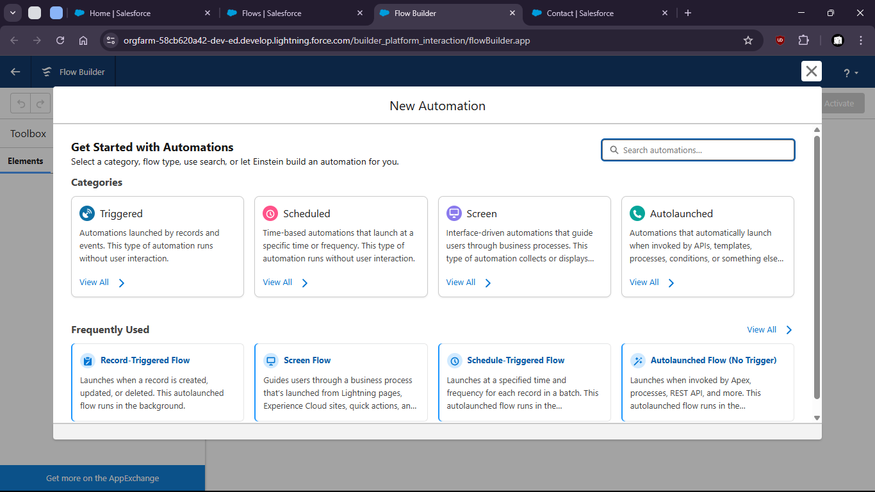

- Select Record Triggered Flow

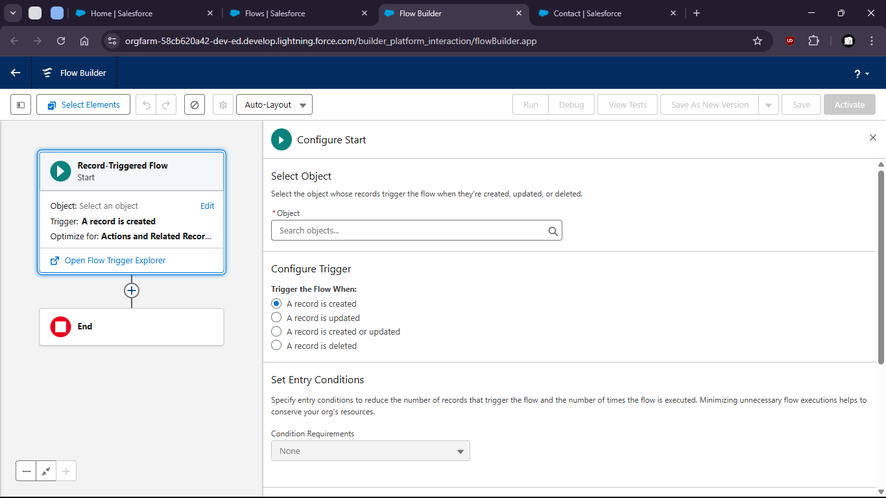

- Select Account as Object

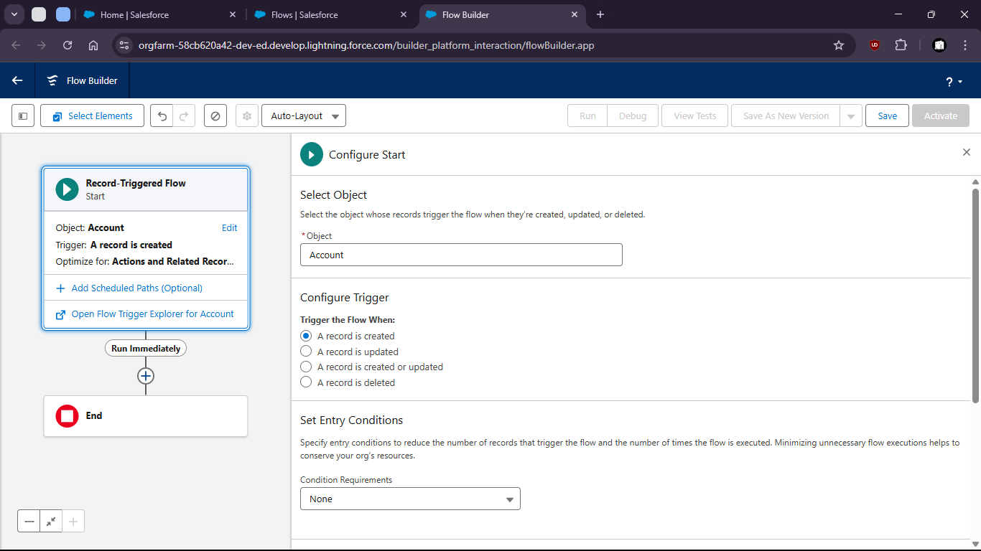

- Add Create Records Element

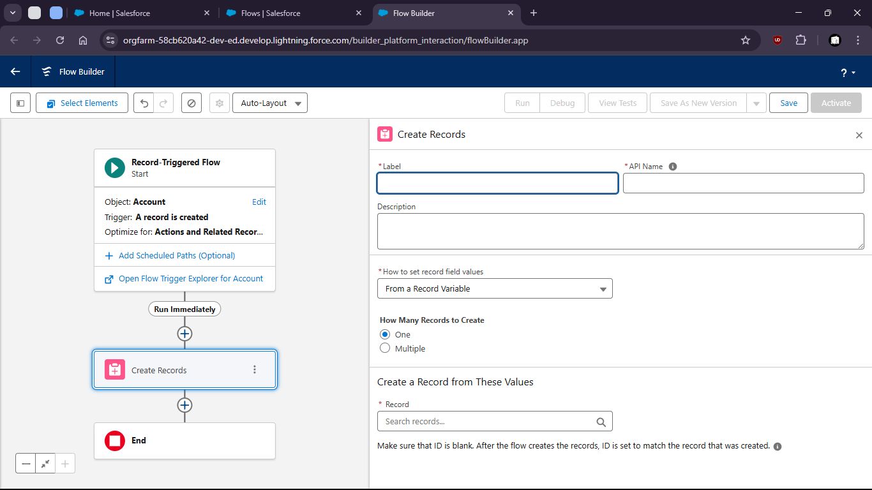

- Fill Up opportunity field values

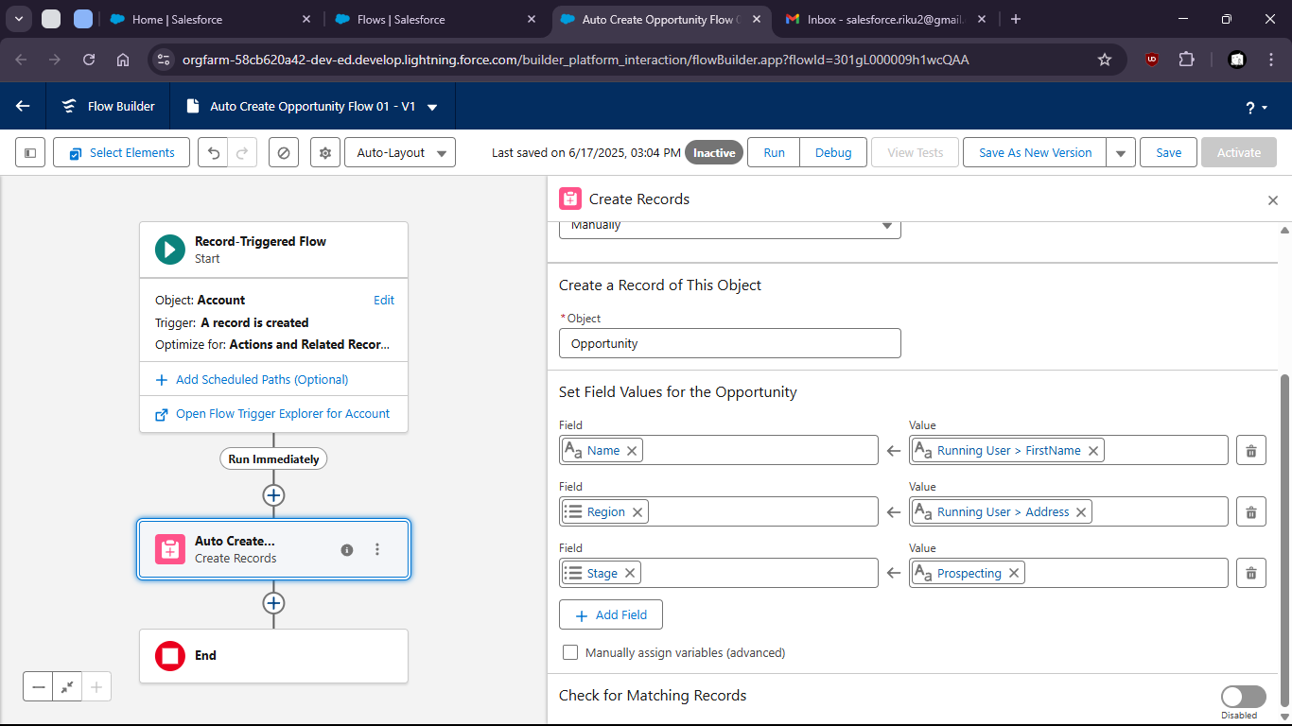

- Save and Activate

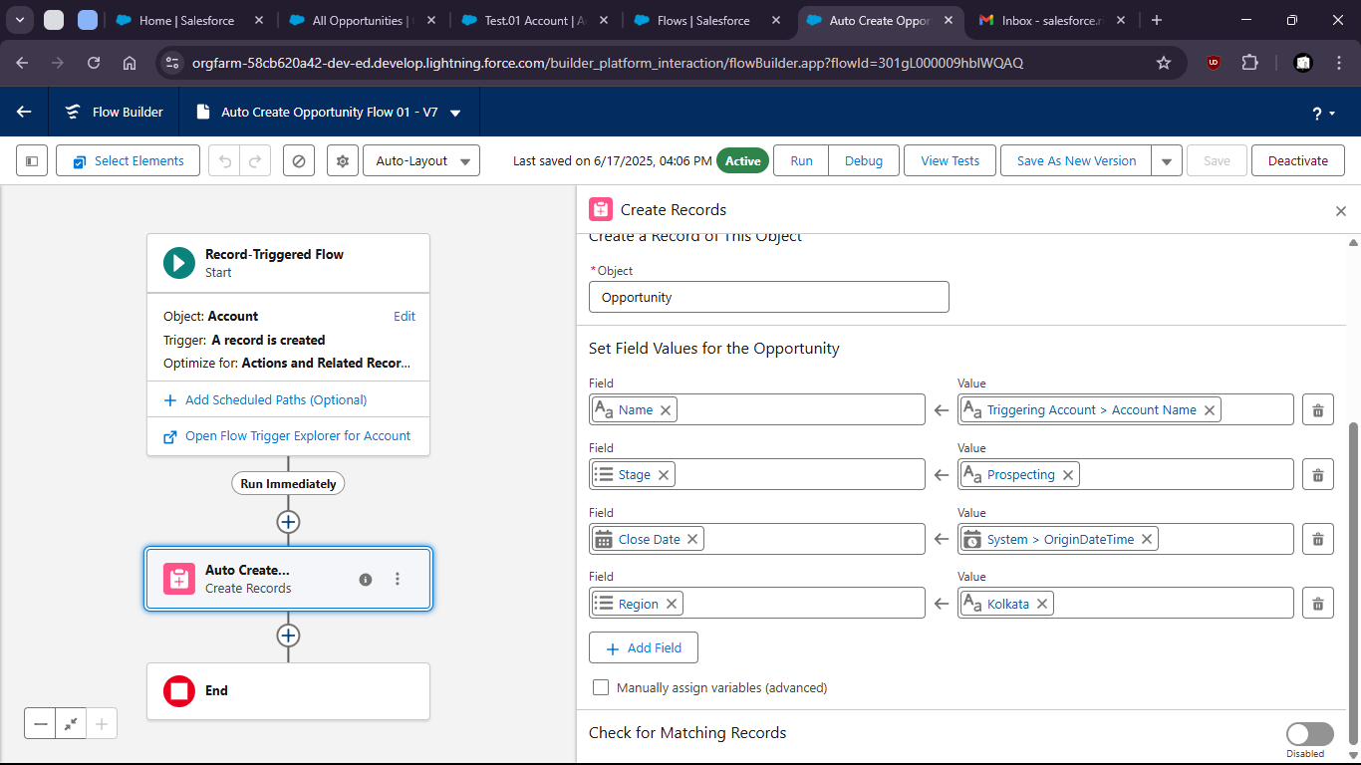

- Now to verify
- Crete a new Account (name: Test Account)

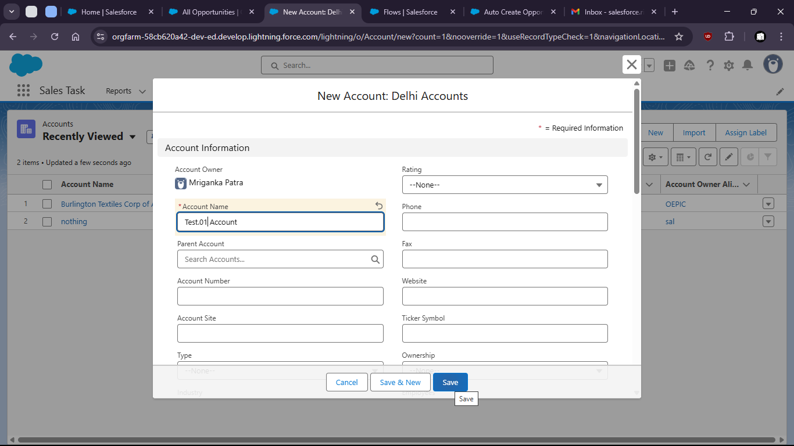

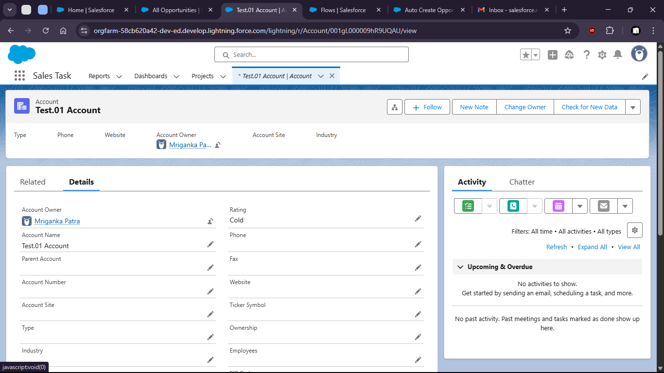

- We can check new opportunity was created

